RESUME

**Costel-Gabi Barbir**

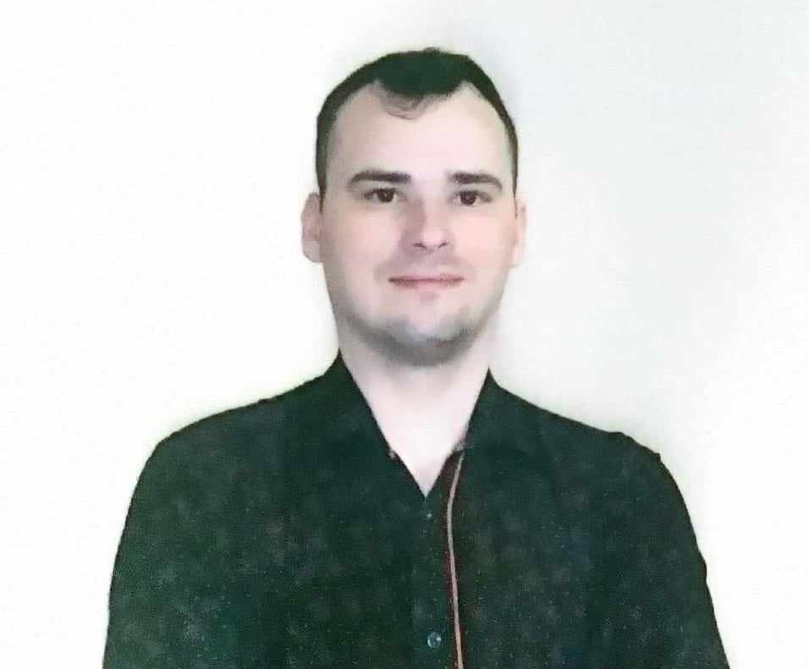  
  
**Contact Information**  
Email: barbircostelgabi@yahoo.com  
Phone: +40730057147  
City: Bucharest  
  
**Professional Experience**  
**Freelancer**  
December 2023 - Present (11 months)  
Remote (Home-based) | Marketing | Advertising / Marketing / PR  
Responsibilities: Social Media, Content Writing, Copywriting, utilizing AI tools for work efficiency, photo-video editing using Canva.  
Skills: Graphic Design, Content Writing, Canva Design, Creative Copywriting  
  
**Public Policy Analyst - Issue Monitoring SRL**  
November 2021 - November 2023 (2 years, 1 month)  
Remote (Home-based) | Media / Internet  
Responsibilities: Monitoring and analyzing legislative and political developments on national, local, and international levels in the field of public policies (health, energy, environmental protection, etc.). Online press monitoring, sending alerts to clients, participating in public debates organized by Ministries or Parliamentary Commissions, writing weekly reports and periodic analyses.  
Skills: Research, Monitoring, Attention to detail, Content Writing, Google Docs, MailChimp, Microsoft Outlook, Proactivity, Planning and Organization, Creativity  
  
  
**Work Execution Tracking Officer - S.C. A. G. Steel Building & Cladding**  
July 2021 (1 month)  
Iasi | Project Management | Construction  
Skills: Microsoft Office, Observation skills, Adaptability, Microsoft Outlook, Communication skills  
  
**Volunteer - League of Philosophy Students in Iasi**  
October 2016 - May 2019 (2 years, 8 months)  
Iasi | NGO / Volunteering | Education / Training  
Participated in trainings and workshops organized by the League, developed skills like effective communication and teamwork. Contributed to organizing and promoting cultural and educational events.  
Skills: Perseverance, Communication, Seriousness, Adaptability, Teamwork, Patience  
  
**Education**  
  
Master's Degree - Alexandru Ioan Cuza University of Iasi, Faculty of Economics and Business Administration  
2019 - 2021 | Human Resource Management | Iasi  
  
Bachelor's Degree - Alexandru Ioan Cuza University of Iasi, Faculty of Philosophy and Social-Political Sciences  
2015 - 2018 | Political Science | Iasi  
  
High School / Vocational School - Nicolae Iorga Technological High School Negresti, Vaslui  
2011 - 2015 | Social Sciences | Negresti  
  
**Certifications**

Relationship Workshop Facilitator (TRANSFORMATION ACADEMY) - Oct 2022  
Skills: Interpersonal relationship management, Communication strategies, Conflict management, Emotional intelligence  
  
**Languages**

English: Advanced  
French: Beginner  
  
**Skills**

General Skills: Communication, Negotiation, Numerical and Analytical skills, Creativity, Flexibility and Adaptability, Projects, Perseverance, Empathy, Autonomy, Integrity, Openness to new ideas, Teamwork, Proactivity.  
  
**Hobbies**

Reading, Personal Development, Learning, Motivational Materials