**SHIRLEY FAYE P. DURAN**

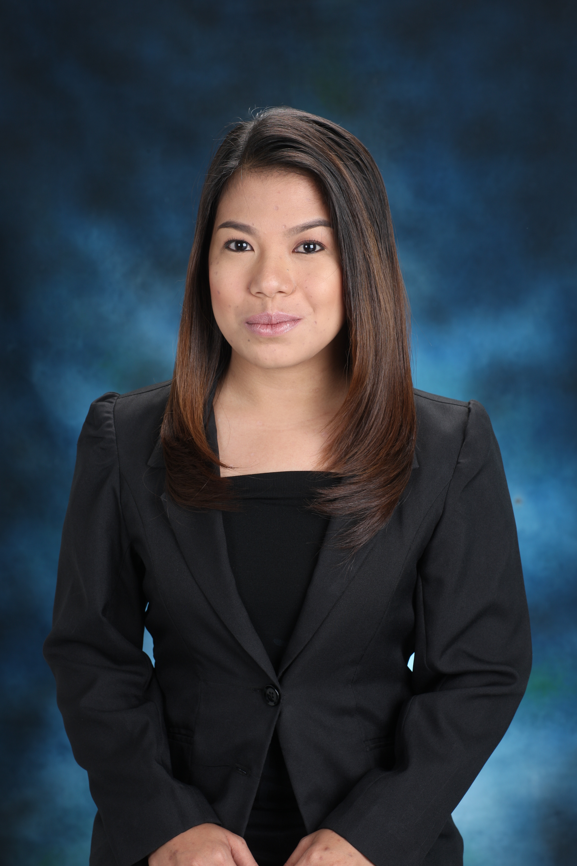

Address: Block7 Lot 19 Ivory Street Perpetual Village, Mambog 1

Bacoor, Cavite

Mobile: 09387185893

Email:**fayeshirley10@gmail.com**

**OBJECTIVE:**

To acquire valuable knowledge and skills to complement those that I have learned from school in an actual job environment. In return, I offer my service and determination to contribute for the company’s success.

**EDUCATIONAL BACKGROUND:**

**Tertiary:**Cavite State University-Imus Campus 2012 - 2018

City of Imus, Cavite

BS Office Administration

**Secondary:**Academy of St. Joseph 2007 - 2011

Claveria Cagayan

**Elementary:**CapanikianElementary School 2001- 2007

Claveria Cagayan

**PERSONAL INFORMATION:**

**Age:** 28 years old

**Birthday:** February 10, 1995

**Birth Place:** Claveria Cagayan

**Mother’s Name:** Lina P. Duran

**Occupation:** Housewife

**Civil Status:** Single

**Citizenship:** Filipino

**SKILLS:**

* MS PowerPoint Presentation,Publisher,Excel Word ,Movie Maker and Internet Application
* Proficiency in English and Filipino language ,by written, oral, communication and to interact other people surround me

**WORK EXPERIENCE:**

Local Government of Imus, Cavite (Engineering Department)

(On the Job Training)

200 hrs.

Encoder

April-June 2015

Jen Print Incorporated

Arayat St. GVMC bldg. Mandaluyong City

(On the Job Training)

300 hrs.

July - October 2016

Explorer Freight Corporation

G.S Cuerda Building Molino Boulevard

Niog III, Bacoor Cavite

Documentation Staff

June 2018- April 2021

**SEMINARS ATTENTED:**

* **Innovation and Strategy**: **The Key for Success**,

Imus Pilot Multi-Purpose Hall, city of Imus, Cavite (Feb. 28, 2012)

* **Class of Corporate Social Responsibility: Shaping the Future**,

SM City Bacoor, Bacoor City, Cavite (Sep. 28, 2012)

* **Innovating Customer Relations and Stress Management,**

FRC Mall, Imus City, Cavite (Oct. 22, 2012)

* **Disaster Risk Reduction and Management and Climate ChangeAdaptation**,

Cavite State University, City of Imus, Cavite(Sep. 25, 2014)

* **Sustaining Excellence in Office Administration**,

DeLaSalle University, Dasmariñas City, Cavite October 3, 2015

*I hereby certify that the above information is true and correct to the best of my knowledge and belief*