CURRICULUM VITAE

Govind Rao
C/O Sankar Rao
1/OS/78, UNIT NO -2
OLD SETTLEMENT
POST – KHARAGPUR
DIST –WEST MIDNAPORE
PIN -721301.

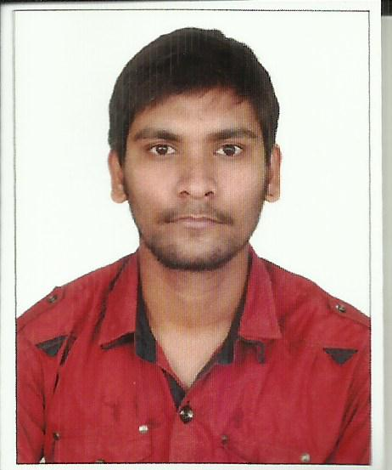

Mobile No: +91 9749015122
E-Mail ID:govindgcetts1908@gmail.com

CAREER OBJECTIVES

To be part of an organization where I can enhance my knowledge and apply my skills to the best of my knowledge and thus reach a meaningful position in my life.

PERSONAL DETAILS

Name | : | Govind Rao
Father’s Name | : | Sankar Rao
Date of birth | : | 13-11-1992
Gender | : | Male
Nationality | : | Indian
Religion | : | Hindu
Marital status | : | Single

ACADEMIC QUALIFICATION

QUALIFICATION | SCHOOL/COLLEGE | BOARD /UNIVERSITY | YEAR | PERCENTAGE /SGPA
B.TECH | GCETTS | W.B.U.T | 2015 | 7.33
12th | BHPV SR SEC SCHOOL VIZAG A.P | CBSE | 2011 | 56.4
10th | KENDRIYA VIDYALAYA NO -2 ,KGP | CBSE | 2009 | 78.2

COLLEGE NAME: GOVT COLLEGE OF ENGINEERING& TEXTILE TECHNOLOGY SERAMPORE.
DURATION: 2011 TO 2015.
STREAM: COMPUTER SCIENCE AND ENGINEERING.
SEMESTER | 1st | 2nd | 3rd | 4th | 5th | 6th | 7th | 8th
SGPA | 6.87 | 7.41 | 6.97 | 7.05 | 7.15 | 7.35 | 8.52 | 8.67

TECHNICAL QUALIFICATION

Computer Application: MS OFFICE, MS WORD., POWERPOINT

EXPERIENCE

CURRENTLY RUNNING A DTDC FRANCHISE FROM PAST 8 MONTHS.

ACADEMICS ACHEIVEMENTS

FGGFGFGAAAAAAAAAAAACHEIVEMENTS:

Participated in workshop on Ethical Hacking and Information Security Level -1 held in our college on 6th &7th February 2013.
Got merit certificate for participating in Dristi, an All India Aptitude Test conducted in 2007.

PERSONAL SKILLS

Positive & optimistic attitude.
Energetic & result oriented.
HOBBIES

Listening to music
Playing cricket

LANGUAGES KNOWN :-

English
Hindi
Telugu

If you favor me with an appointment, I shall do my work with most conscientiously. Looking forward to a bright future in your esteemed organization.

DECLARATION :

The above information is true to the best of my knowledge and belief without any discrepancy.

Thanking You
Yours Truly,

GOVIND RAO

