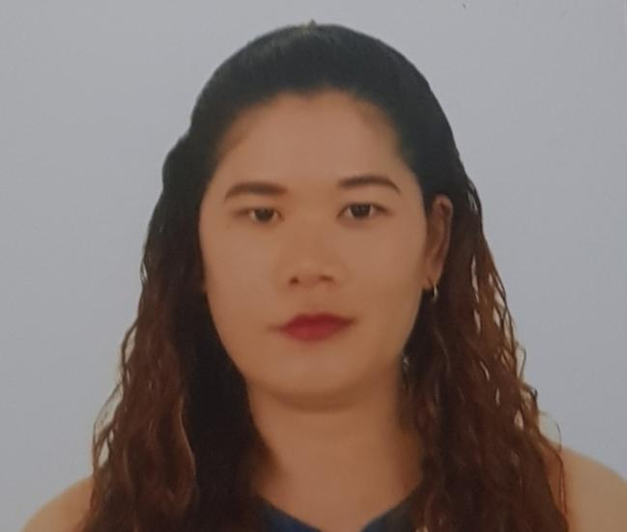

**JANICE P. BONTIA RRT**

Full time Medical coder

Diagnostic Radiographer-

Poblacion Ramon Magsaysay Zamboanga del Sur, Philippines

Mobile Numbe: +639778218428

Email Address: [janicebontia8@gmail.com](mailto:janicebontia8@gmail.com)

**PERSONAL INFORMATION**

Age : 30

Date Of Birth : 30 March 1989

Civil Status : Single

Gender : Female

Citizenship : Filipino

**EDUCATIONAL BACKGROUND**

Bachelor Of Science In Radiologic Technologist

Iligan Medical Center College

Pala-o Iligan City , Philippines

2010

**LICENSURE**

Professional Regulation Commission for Radiologic Technologist License

Manila, Philippines

License No. 0008440

Valid Until 30 March 2022

**PROFESSIONAL EXPERIENCE**

**Global Healthcare**

Modesto California USA

Medical Encoder (Oasis 2021-present)

**Hofilena Hospital**

F.S. Pajares Street, Pagadian City, Philppines

Position: Radiographer

Department/Unit: Radiology Department

Period: December 2013- Dec 2018

**Sibud County Hospital -1year**

Titay, Zamboanga Sibugay, Philippines

Position: Radiographer

Department/Unit: Radiology Department

Period: October 20 11- October 2012

**Ramiro Community Hospital - 1 year**

Tagbilaran City, Bohol, Philippines

Position: Radiographer

Department/ Unit: Radiology Department

Period: August 2010- August 2011

**TRAININGS/CERTIFICATES**

* **Ct-Scan Training Course-** July 2- August 31, 2018

Paideia Professional Development Institute. INC.

Metro Manila, Philippines

* **MRI Training Course**- September 14- October 18, 2018

Paideia Professional Development Institute. INC.

Metro Manila, Philippines

**COMPUTER TECHNICAL SKILLS**

* PACS (Pictures Archiving Communication System
* RIS ( Radiology Information System)
* SAM SYSTEM

**REFERENCES**

Available upon request.

