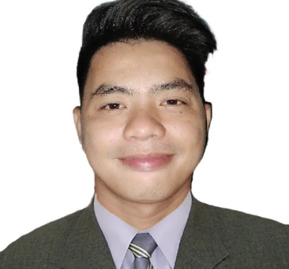

Kenneth S. Palomo

|  |
| --- |
| EMAIL: [palomoserrano009@gmail.com](mailto:serranopalomo009@gmail.com)  MOBILE NO. 0927-132-8995  ADDRESS: Zone2 Brgy. Neighborhood, Bato, Camarines Sur |

**OBJECTIVES**

OBJECTION

**I am seeking for a career opportunity wherein I can utilize my skills and knowledge to contribute to the growth of the firm as well as to its success.**

SKILLS AND QUIALIFICATION

**SKILLS AND QUALIFICATION**

* **Good communicating and persuasive skills**
* **Efficient leadership skills and willingness to learn more**
* **Knowledgeable with basic computer ( MS word, Excel and PowerPoint )**
* **Hard working and willing to work under pressure**
* **Excellent to negotiates and reduce pricing in HOA, and Brgy’s Permit**
* **Excellent for Securing Permits and Project Prior.**

**WORK EXPERIENCE**

WORK EXPERIENCE

ROW Officer

Machine Operator

**Orocan DITO Telecommunity Project**

**January 24, 2011 to January 27, 2011 October 14, 2020 to April 14, 2021**

**Plastic Fabrication Company Ruixintong INC**

**Obando, Bulacan Bacoor Cavite**

Sales Associate

Promodiser

**Alaska Adidas**

**August 23, 2008 to February 23, 2009 March 14, 2009 to March 14, 2010**

**Spank Lowe Group of Company Orange Power Network, INC**

**Makati City Pasig City**

**EDUCATIONAL BACKGROUND**

EDUCATIONAL BACKGROUND

**TERTIARY : AIE College ( Asian Institute for E-commerce )**

**Information Technology ( I.T )**

**2006 – 2008**

**SECONDARY : Caloocan High School**

**2002 – 2006**

**ELEMENTARY : Caloocan Central Elementary School**

**1996 – 2002**

EDUCATIONAL BACKGROUND

**PERSONAL INFORMATION**

**BIRTHDAY : January 9, 1990**

**PLACE OF BIRTH : Tondo Manila**

**AGE : 33 yrs Old**

**GENDER : Male**

**CIVIL STATUS : Single**

**CITIZENSHIP : Filipino**

**RELIGION : Born Again**

**HEIGHT : 5’6**

***I hereby that the above information are true and correct to the best of my knowledge.***



**KENNETH S. PAMOLO**

**APPLICANT SIGNATURE**